HR Project Workflow Screenshots

**Cleaning**

1. Replaced ambiguous or unclear column names

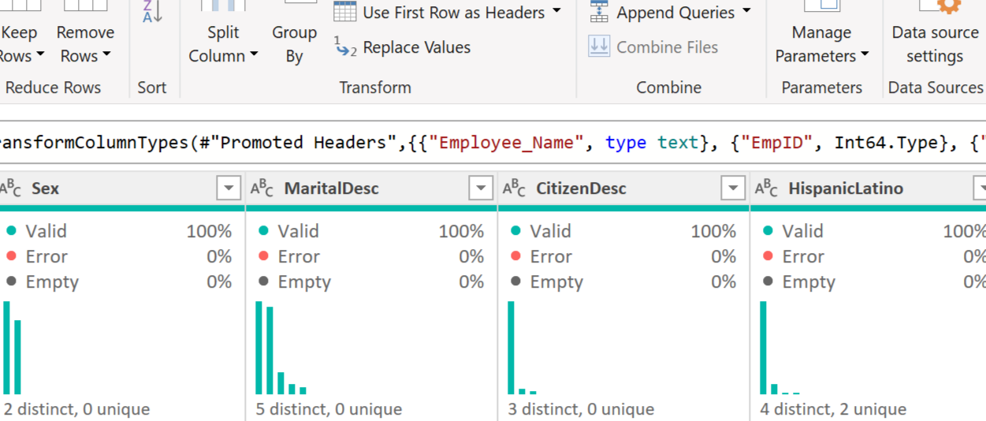

1. Removed non-essential columns for analysis

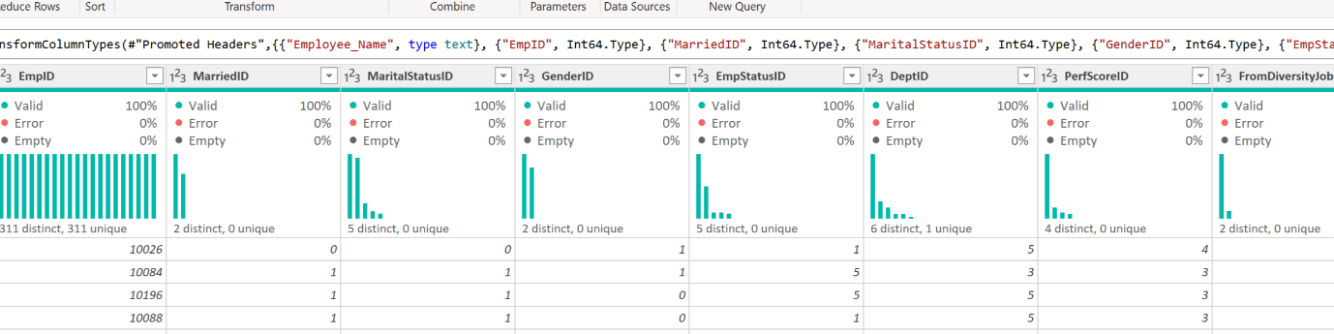

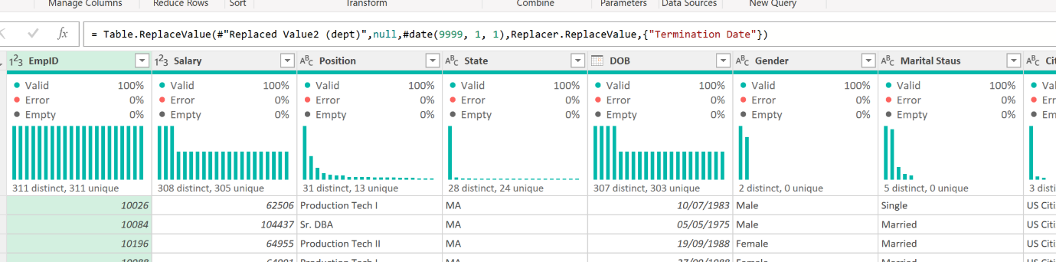

1. Changed data types. Specially text data type date columns into date type columns

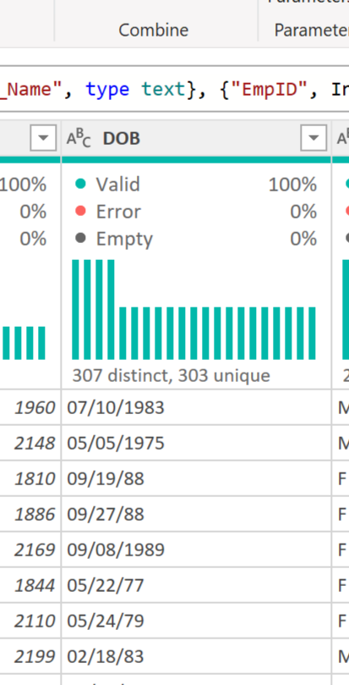

1. Created separate first and last name columns

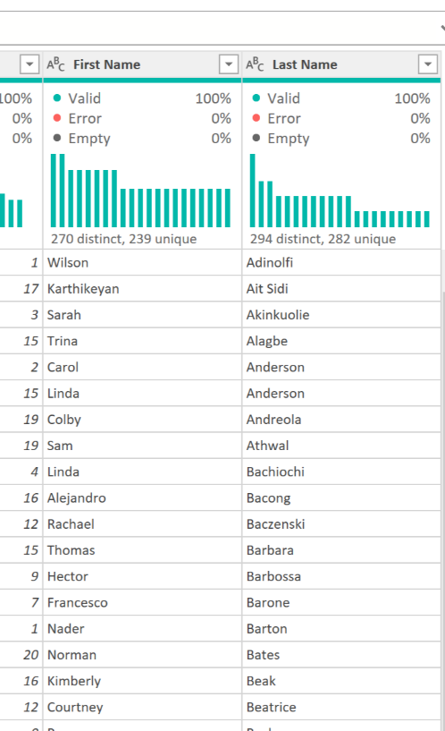

1. Trimmed whitespace from identical position titles to remove ambiguity

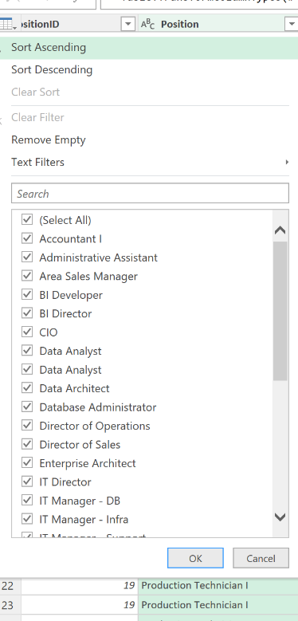 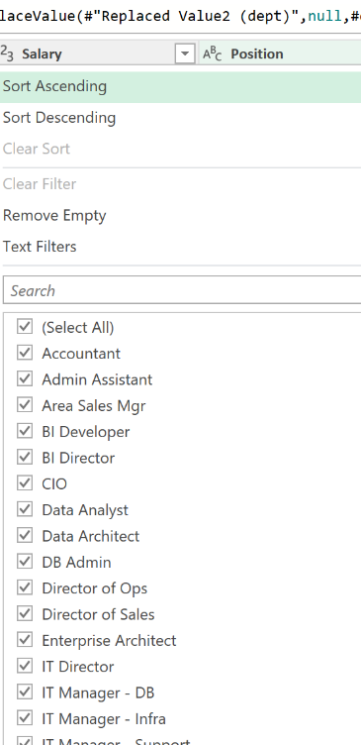

1. Changed syntax errors – punctuation, editing, etc

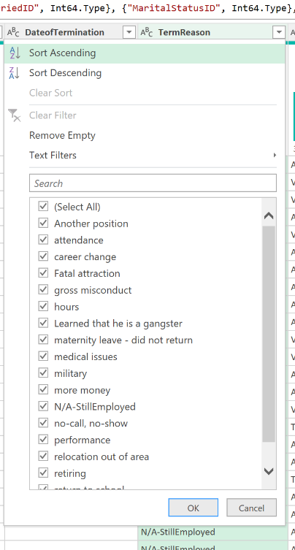 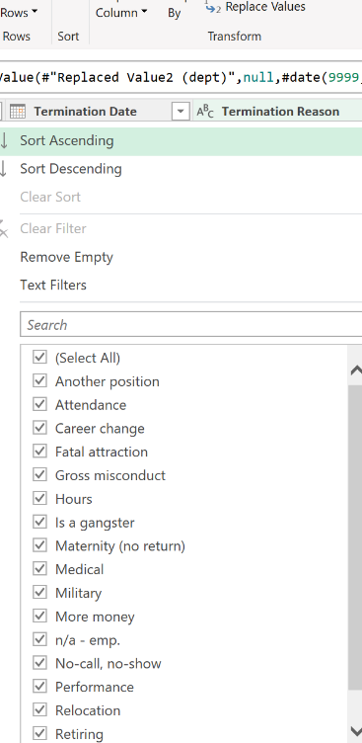

**Transformation**

1. Calculated Days of Service and Age columns

1. Calculated Years of Service and Work Days columns

1. Calculated Absence rate as a percentage fraction and created conditional Salary Band column

1. Create conditional Age Band and Tenure Band grouped column

1. Created addition column to combine satisfaction and engagement score

